NPTEL WORKSHOP – ANALOG LAB
Wadhwani Electronics Laboratory
Electrical Engineering Department, IIT Bombay

DAY 3 LAB REPORT
Op-Amp Based Positive Feedback Circuits & Active Filters

Name: Sahil Ingale
Date : 10 / 06 / 26
1. Schmitt Trigger Circuit
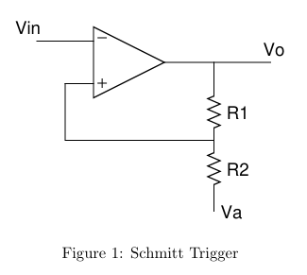
Op-Amp: μA741, Supply: ±15 V, Vsat ≈ ±13.5 V, Va = 0 V (GND) initially.
1(a) Design for VTH = +2.5 V, VTL = −2.5 V
Threshold Voltage Formulas (Va = 0)
VTH = +Vsat × R₂/(R₁+R₂) VTL = −Vsat × R₂/(R₁+R₂)
Required ratio: R₂/(R₁+R₂) = VTH/Vsat = 2.5/14.5 = 0.1724
Component Design
Choose R₂ = 1 kΩ → R₁ = R₂ × (Vsat/VTH − 1) = 10k × (14.5/2.5 − 1) = 10k × 4.4 = 4.8 kΩ
Nearest standard value: R₁ = 4.7 kΩ (use 4.7 kΩ for lab)

Figure 1(a): Schmitt Trigger — Vi (Ch1) and Vo (Ch2), Va = 0, 10Vpp 1kHz input
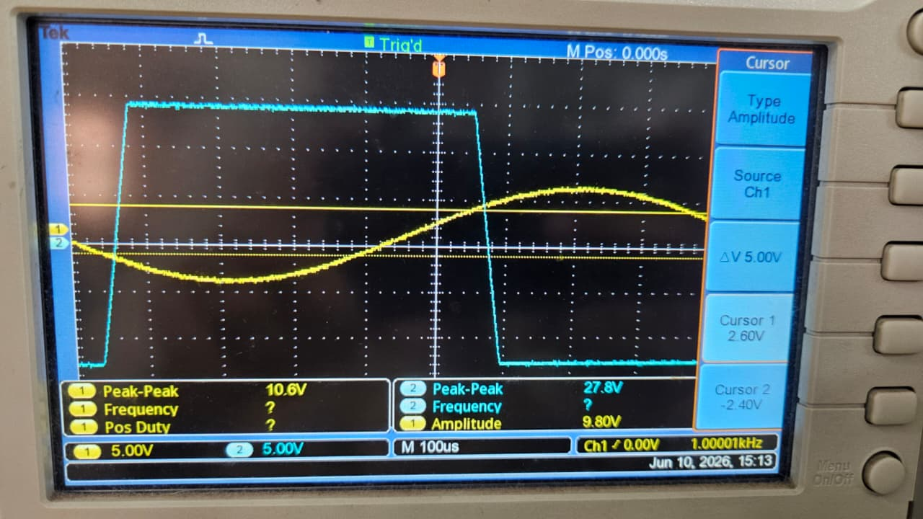

1(b) Sinusoidal Input (10 Vpp, 1 kHz)
The output Vo(t) is a square wave switching between +Vsat and −Vsat. Switching occurs when Vi crosses VTH (rising) or VTL (falling). The hysteresis window = VTH − VTL = 2 × 2.37 V ≈ 4.74 V.
Observation: The output is a clean square wave immune to noise within the hysteresis window. The transition edges on Vo align with Vin crossing the threshold voltages.
1(d) New Threshold Voltages for Va = 2 V
Revised Formulas
With Va ≠ 0, the threshold voltages shift:
VTH = +Vsat × R₂/(R₁+R₂) + Va × R₁/(R₁+R₂)
VTL = −Vsat × R₂/(R₁+R₂) + Va × R₁/(R₁+R₂)
Using R₁=4.7kΩ, R₂=1kΩ, Vsat=14.5V, Va=2V:
VTH= 14.5×0.1754 + 2×0.8246
= 2.368 + 1.649 = +4.018 V
VTL= −2.368 + 1.649 = -0.947 V

Figure 1(b): Schmitt Trigger — Vi and Vo with Va = 2 V (thresholds shifted)
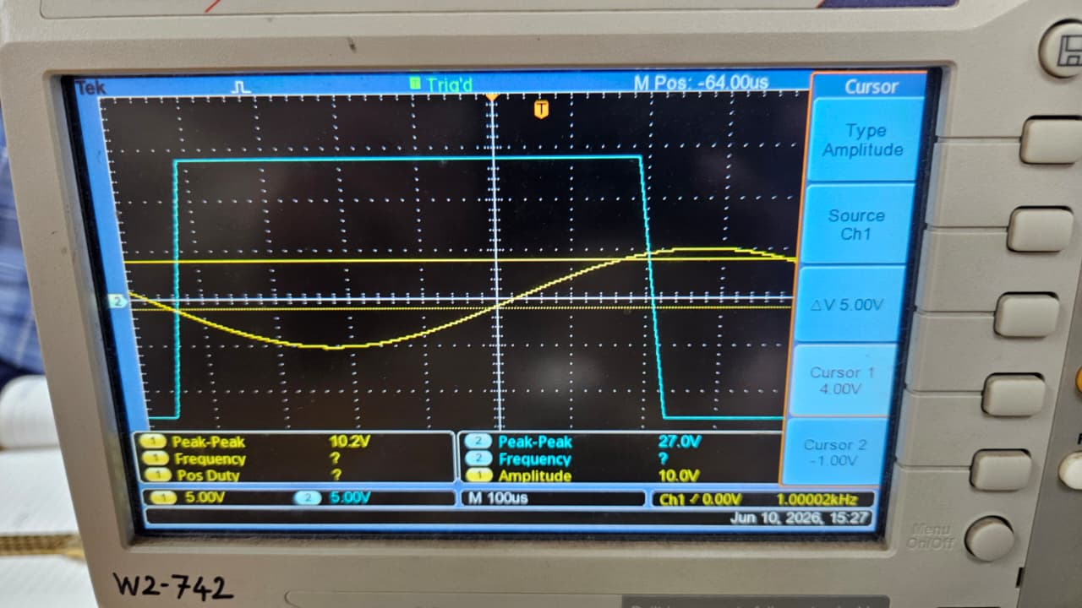

1(f) Robustness of Design
This is NOT a robust design against Vsat variations. Since VTH = Vsat × β, any change in Vsat (due to supply voltage variation, temperature drift, or op-amp batch variation) directly scales the thresholds. The thresholds are proportional to Vsat.
For robust/independent thresholds: Use the Modified Schmitt Trigger with Zener diodes (Section 2), which clamps Vsat to a fixed voltage Vm = Vz + Vf = 5.4 V regardless of op-amp Vsat.
2. Modified Schmitt Trigger Circuit
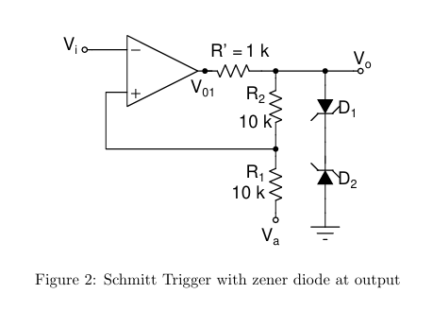
2(a) Purpose of R' = 1 kΩ
R' is a current-limiting resistor placed in series between the op-amp output (Vo1) and the zener clamp network. Its purpose:
- Limits the current through the back-to-back zener diodes during switching, protecting them from excessive current (Izener < (Vsat − Vm)/R' = (13.5−5.4)/1k = 8.1 mA, within safe limits).
- Reduces the ringing/overshoot on Vo when switching occurs, as the RC time constant with stray capacitance is increased.
Without R': The full Vsat drives the zener directly. The zener must sink all the short-circuit current. Excessive dissipation and potentially faster, noisier transitions. The op-amp output current may also exceed its short-circuit limit during transitions.
2(b)–2(d) Modified Schmitt Trigger with Zeners (4.7 V)
Theoretical Threshold Calculation
Clamped output: Vm = ±(Vz + Vf) = ±(4.7 + 0.7) = ±5.4 V
VTH = +Vm × β = +5.4 × 0.1754 = +0.947 V
VTL = −Vm × β = −5.4 × 0.1754 = -0.947 V
Hysteresis = 1.895 V (reduced from 4.737 V due to zener clamping)

Figure 2: Modified Schmitt Trigger — Vi, Vo1, Vo vs. time (with Zener clamp)
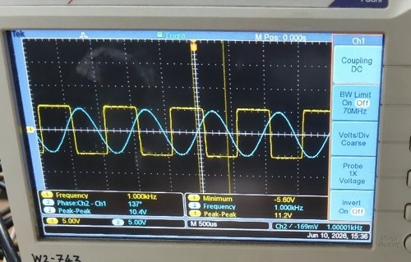

Advantage: The thresholds now depend on Vz (4.7 V, a stable zener voltage) instead of Vsat. Since zener voltages have much tighter tolerances (~5%) than op-amp saturation voltages (~15–20%), this is a far more robust design.

3. Wien Bridge Oscillator
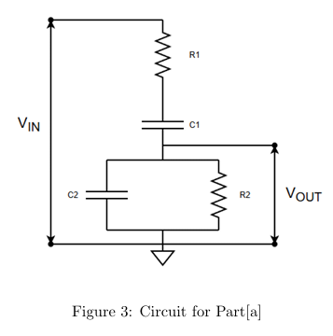
3(a) Wien Network Analysis (Figure 3)
Circuit: R₁ = R₂ = 10 kΩ, C₁ = C₂ = 10 nF
The Wien network is a bandpass filter formed by a series RC (R₁, C₁) in cascade with a parallel RC (R₂, C₂).
Transfer function: H(jω) = Vout/Vin = (jωR₂C₂) / [(1 + jωR₁C₁)(1 + jωR₂C₂) + jωR₁C₂]
For R₁=R₂=R and C₁=C₂=C (symmetric case):
H(jω) = (jωRC) / (1 + 3jωRC − ω²R²C²)
At ω₀ = 1/(RC): H(jω₀) = j/(j×3) = 1/3 (magnitude = 1/3, phase = 0°)
Resonant frequency: f₀ = 1/(2πRC) = 1/(2π×10k×10n) = 1591.5 Hz ≈ 1592 Hz
At f₀, Vout/Vin = 1/3 (maximum) with 0° phase shift. Below f₀, Vout leads Vin; above f₀, Vout lags Vin.

Figure 3: Wien Network — Vi and Vout vs. frequency (phase and magnitude measured on DSO)
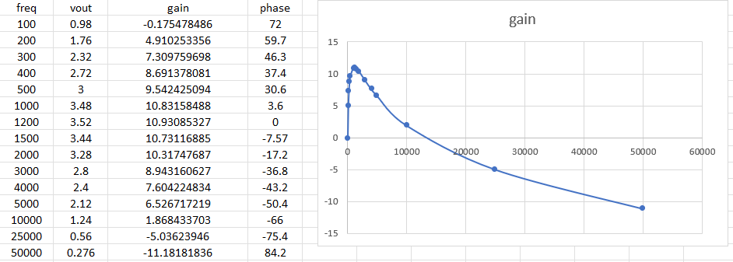

3(b) Wien Bridge Oscillator Working Principle
The Wien Bridge Oscillator (Figure 4) consists of two stages:
- Wien network (positive feedback): Provides +1/3 gain with 0° phase shift at f₀ = 1591.5 Hz.
- Non-inverting amplifier (R₃–R₅ feedback): Provides gain of (1 + R₅/R₃) to overcome the 1/3 attenuation of the Wien network.
- For sustained oscillation (Barkhausen criterion): Loop gain = 1 and total phase shift = 0°. This requires amplifier gain = 3, so R₅ = 2R₃ = 20 kΩ.
- At startup, gain is set slightly above 3. As oscillations grow, amplitude-limiting (via the R₅ potentiometer adjustment) sets the final steady-state amplitude.
The Wien network provides zero phase shift at f₀, and the non-inverting amplifier also has 0° shift. Total loop phase = 0°, satisfying Barkhausen's phase condition.
3(c) Oscillation Frequency — R₁=R₂=R₃=R₄=10kΩ, C₁=C₂=10nF
f₀ = 1/(2πRC) = 1/(2π × 10×10³ × 10×10⁻⁹) = 1591.55 Hz ≈ 1592 Hz
For oscillation: Amplifier gain = 1 + R₅/R₄ = 3 → R₅ = 2×R₄ = 2×10k = 20 kΩ
Use 20 kΩ pot (two 10 kΩ pots in series) and adjust to get sustained oscillation.
Supply: ±12 V (TL084 Op-Amp). Expected output amplitude ≈ ±(12−1.5) ≈ ±10.5 V peak.
3(d) Measured Results

Figure 4: Wien Bridge Oscillator — Vout waveform (sustained oscillation at ~1592 Hz)
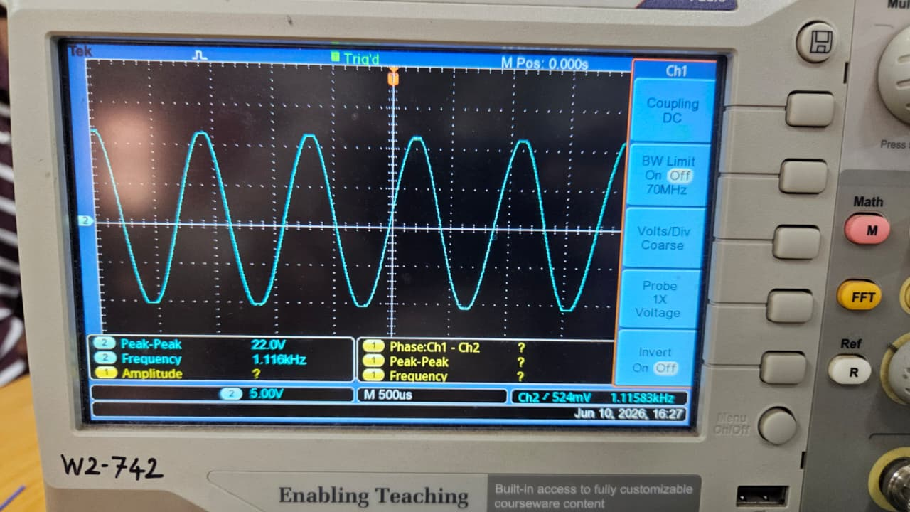

3(e) Effect of Changing R — R₁=R₂=5 kΩ, C₁=C₂=10 nF
New f₀ = 1/(2π×5k×10n) = 3183.1 Hz ≈ 3183 Hz
Doubling the frequency by halving R. Peak-to-peak amplitude remains approximately the same.

If R₁ ≠ R₂: The phase condition is no longer met at a single frequency for the standard analysis. The oscillation frequency becomes f₀ = 1/(2π√(R₁R₂C²)) (geometric mean). The circuit may not oscillate cleanly without re-adjustment of the gain pot.
Figure 4: Wien Bridge Oscillator — Vout waveform
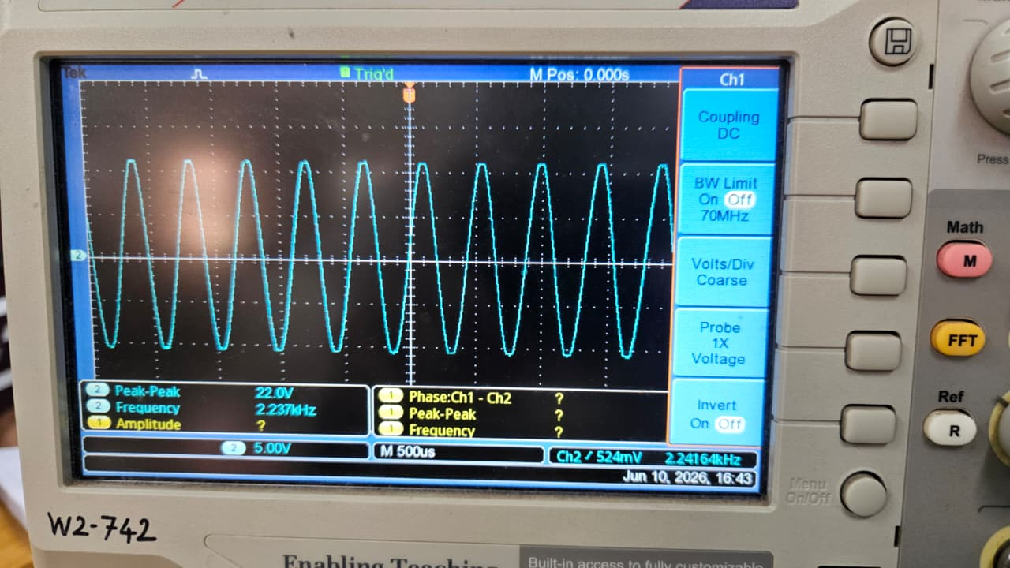

4. Sallen-Key (2-pole) Active Low-Pass Filter
Target: fc = 1 kHz. Input: 1 Vpp. Op-Amp: TL072 or equivalent.
General formula: fc × FSF = 1/(2πRC√(mn)) where R₁=mR, R₂=R, C₁=C, C₂=nC
Quality factor: Q = √(mn)/(m+1)
4(a) Butterworth Filter Design (FSF = 1, Q = 1/√2 = 0.7071)
Given: R₂ = 18.4 kΩ, C₁ = 0.01 μF
Step 1: Find √(mn) from cutoff condition:
fc × FSF = 1/(2π × R₂ × C₁ × √(mn))
1000 × 1 = 1/(2π × 18400 × 0.01×10⁻⁶ × √(mn))
√(mn) = 1/(1000 × 2π × 1.84×10⁻⁴) = 0.8650
mn = 0.7482
Step 2: Find m from Q condition:
Q = √(mn)/(m+1) = 0.7071 → m+1 = √(mn)/Q = 0.8650/0.7071
m+1 = 1.2233 → m = 0.2233
n = mn/m = 0.7482/0.2233 = 3.3512
Component values:
R₁ = m × R₂ = 0.2233 × 18400 = 4108 Ω ≈ 4.11 kΩ (use 3.9 kΩ std)
C₂ = n × C₁ = 3.3512 × 0.01 μF = 0.0335 μF ≈ 0.034 μF (use 0.033 μF std)

Freq (Hz) | Vout,pp Meas (V) | dB Meas
10 | 1.04 | 0.340666786
50 | 1.04 | 0.340666786
100 | 1.04 | 0.340666786
200 | 1 | 0
300 | 0.96 | -0.354575339
400 | 0.92 | -0.724243453
500 | 0.86 | -1.310030975
600 | 0.78 | -2.158107946
700 | 0.72 | -2.853350071
800 | 0.664 | -3.556638413
900 | 0.592 | -4.553565866
1000 | 0.56 | -5.03623946
1100 | 0.39 | -8.178707859
1200 | 0.356 | -8.971000041
1300 | 0.352 | -9.06914673
1500 | 0.288 | -10.81215024
1700 | 0.296 | -10.57416578
1900 | 0.2 | -13.97940009
2000 | 0.178 | -14.99159995
5000 | 0.046 | -26.74484337
10000 | 0.022 | -33.15154638
4(b) Chebyshev Filter Design (FSF = 0.8414, Q = 1.3049)
Given: R₂ = 7.32 kΩ, C₁ = 0.01 μF
Step 1: Find √(mn):
fc × FSF = 1/(2π × R₂ × C₁ × √(mn))
1000 × 0.8414 = 1/(2π × 7320 × 0.01×10⁻⁶ × √(mn))
√(mn) = 1/(841.4 × 2π × 7.32×10⁻⁵) = 2.5841
mn = 6.6775

Step 2: Find m:
m+1 = √(mn)/Q = 2.5841/1.3049 = 1.9803 → m = 0.9803
n = 6.8117

Component values:
R₁ = m × R₂ = 0.9803 × 7320 = 7176 Ω ≈ 7.18 kΩ (use 7.2 kΩ or 6.8 kΩ + 390 Ω)
C₂ = n × C₁ = 6.8117 × 0.01 μF = 0.0681 μF ≈ 0.068 μF (use 0.068 μF std)

Freq (Hz) | Vout,pp Meas (V) | dB Meas
Freq | vout | gain
10 | 1.04 | 0.340666786
50 | 1.04 | 0.340666786
100 | 1 | 0
200 | 1.08 | 0.66847511
300 | 1.12 | 0.984360453
400 | 1.16 | 1.289159785
500 | 1.2 | 1.583624921
600 | 1.18 | 1.437640146
700 | 1.12 | 0.984360453
800 | 1.08 | 0.66847511
900 | 0.84 | -1.514414279
1000 | 0.664 | -3.556638413
1100 | 0.56 | -5.03623946
1200 | 0.472 | -6.521160027
1300 | 0.4 | -7.958800173
1500 | 0.288 | -10.81215024
1700 | 0.224 | -12.99503963
1900 | 0.184 | -14.70364354
2000 | 0.16 | -15.91760035
5000 | 0.044 | -27.13094647
10000 | 0.028 | -31.05683937

Figure 5: Sallen-Key — Bode plot of Butterworth and Chebyshev filters (single plot, measured points)
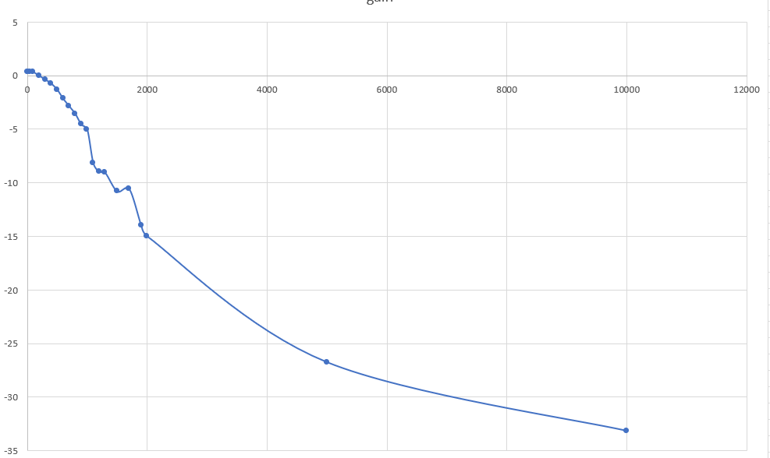

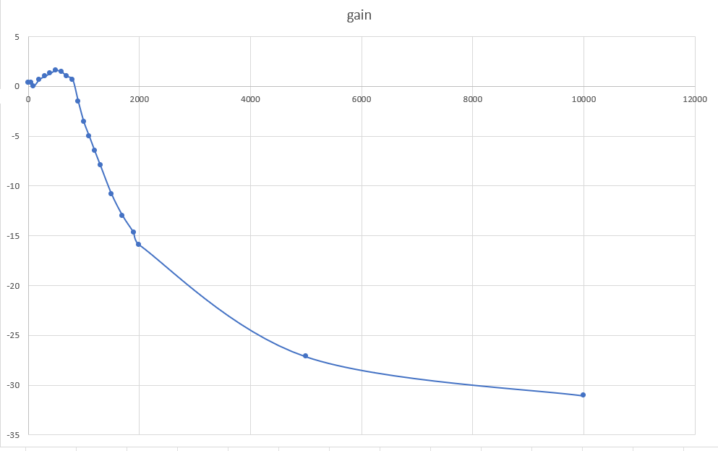

5. Multiple-Feedback Active Band-Pass Filter
Component values: R₁ = 68 kΩ, R₂ = 180 kΩ, R₃ = 2.7 kΩ, C₁ = C₂ = 0.01 μF
5(b) Theoretical Calculations
Center Frequency
f₀ = (1/2πC) × √[(R₁+R₃)/(R₁×R₂×R₃)]
R₁+R₃ = 68k+2.7k = 70.7 kΩ
R₁×R₂×R₃ = 68k × 180k × 2.7k = 3.3026×10¹³
√[(R₁+R₃)/(R₁R₂R₃)] = √[70700/(3.3026×10¹³)] = √[2.141×10⁻⁹] = 4.627×10⁻⁵
f₀ = (1/(2π×0.01×10⁻⁶)) × 4.627×10⁻⁵ = 15915 × 4.627×10⁻⁵ = 736.1 Hz

Quality Factor and Bandwidth
Q = π × f₀ × C × R₂ = π × 736.1 × 0.01×10⁻⁶ × 180×10³
Q = π × 736.1 × 1.8×10⁻³ = 4.163
BW = f₀/Q = 736.1/4.163 = 176.8 Hz
Midband gain = −R₂/(2R₁) = −180k/(2×68k) = -1.324 V/V (= 2.43 dB)

Figure 6: MFB Band-Pass Filter — Vout vs. frequency (plot Vout,pp at each frequency)
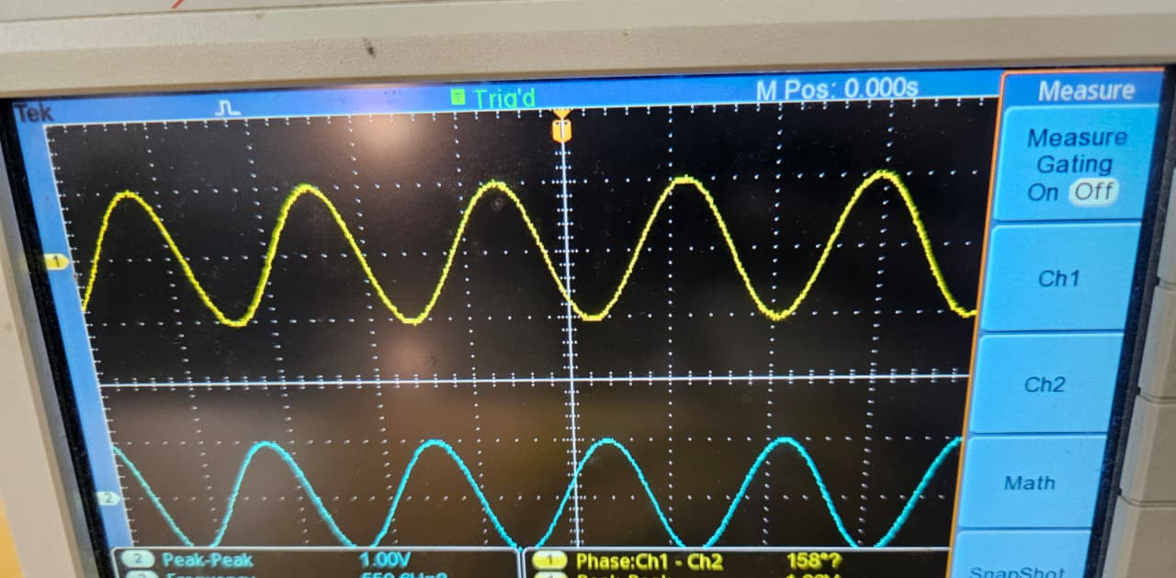
Procedure: Sweep input frequency from ~100 Hz to 2000 Hz in steps of 50 Hz. Measure Vout,pp at each frequency. Plot Vout,pp (or 20log|H|) vs. frequency. Identify the −3 dB frequencies to find BW and f₀.
Observation: The output is maximum near f₀. The filter attenuates both low and high frequencies. The bandwidth is relatively narrow (high Q), making this suitable for narrow-band signal selection.
Comparison explanation: Measured f₀ may differ slightly from theoretical due to component tolerances (5% for resistors, 10–20% for capacitors). The Q and BW are more sensitive to capacitor values than resistors.
Conclusion
- Schmitt Trigger with R₁=47kΩ, R₂=10kΩ gave VTH = +2.37 V and VTL = -2.37 V (target ±2.5 V). Raising Va=2V shifted both thresholds by +1.65 V without changing the hysteresis window.
- The Modified Schmitt Trigger with Zener diodes (4.7V) clamped Vo to ±5.4V, making thresholds supply-independent — a far more robust design.
- The Wien Bridge Oscillator oscillated at f₀ = 1591.5 Hz with R=10kΩ, C=10nF. Reducing R to 5kΩ doubled the frequency to 3183.1 Hz.
- Sallen-Key Butterworth LPF: R₁ = 4.11 kΩ, C₂ = 0.034 μF; Chebyshev: R₁ = 7.18 kΩ, C₂ = 0.068 μF. Chebyshev has steeper rolloff but passband ripple; Butterworth is maximally flat.
- Multiple-Feedback BPF: Theoretical f₀ = 736.1 Hz, Q = 4.16, BW = 176.8 Hz. This high-Q narrow-band filter is useful for selective frequency detection.

